Prerequisites
Make sure the correct firmware is loaded on the Orcon Wifi Controller
Make sure the Orcon Wifi Controller is connected tot he correct Wifi network
Make sure the Orcon Wifi Controller has a fixed IP address or a reservation in your DHCP server
Install the ESPHome app on the Homey bridge

Adding the controller
Click the blue plus sign to add a new device. A bit counter intuitive: If you ever need to change or review settings, you need to follow the “New Device” procedure until you are in the ESPHome app.


Click New Device.
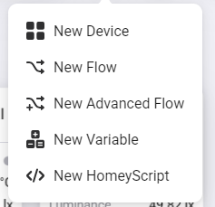

Choose the ESPHome app


Choose the ESPHome Wizard
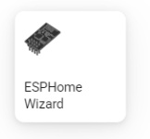

Click the green Connect button to enter the configuration app.
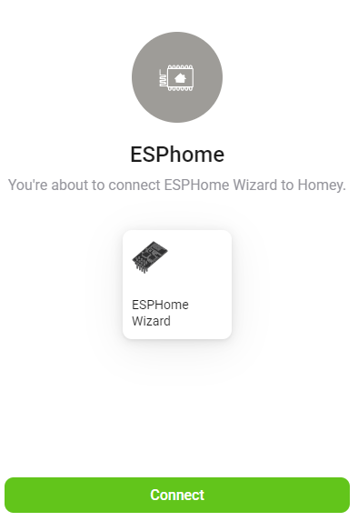

ESPHome configuration menu
The ESPHome menu looks like this:
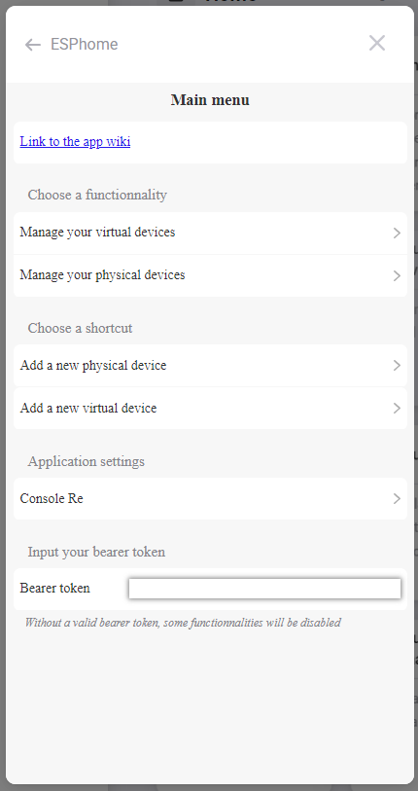

First we need to add the Orcon Wifi Controller, so click on “Add a new physical device”. Give the physical unit a name, for example OrconWifiController. Type in the IP address of the unit. No need to change the Port value unless you modified this yourself when configuring the controller.
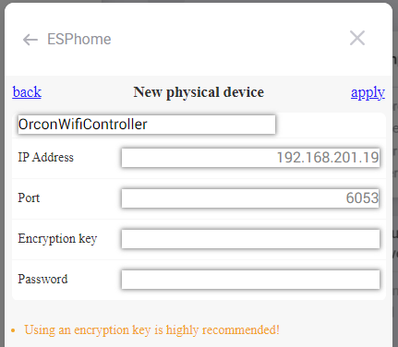
Click apply.

Now that the physical unit has been defined, we need to configure a Virtual Device, so click on “New virtual device”.
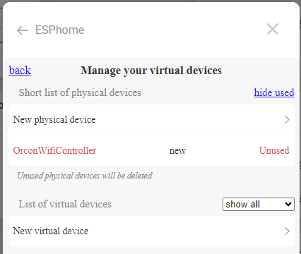

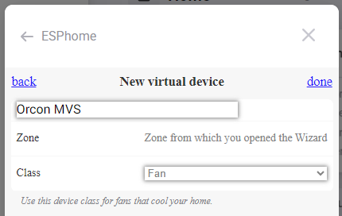
Give the virtual unit a name, for example Orcon MVS, and select Class “Fan”, click on “done”.

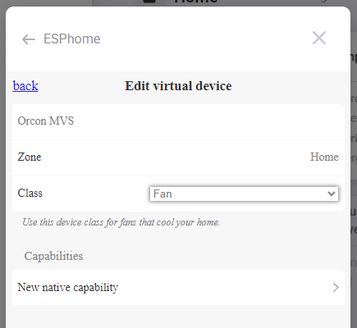
Now click on “New native capability”.

Mapping the capabilities
Now we are going to map the capabilities in the ESPHome app so Homey can use the data and you can manipulate the fan speed. Set the Physical device to your device. If all prerequisites are done correctly, the following list of “native capabilities” should pop up when you click the button:
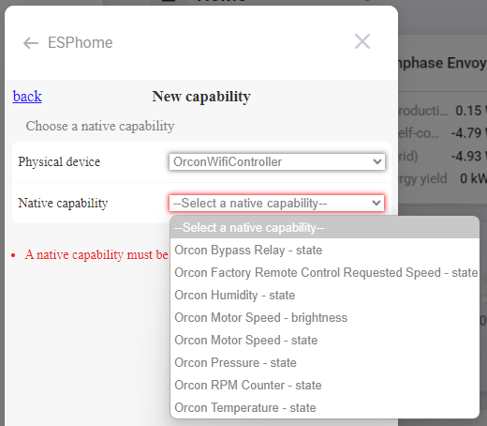
After adding each capability you click on the “New native capability” button until all the capabilities have been mapped.

Bypass Relay state
The Bypass Relay state is an easy one, just set the Type to “onoff” and click “done”.
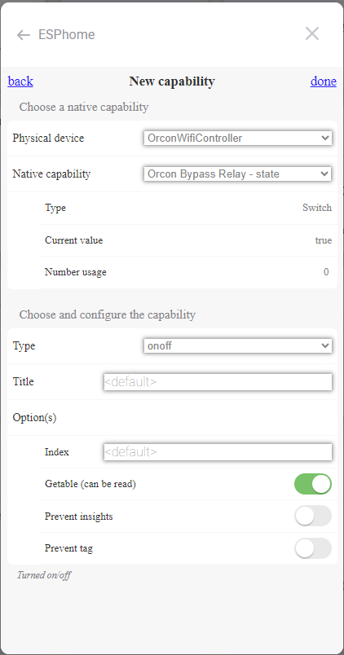
The Bypass Relay state controls the relay on the PCB. If the relay is set to “off” then the unit works with the factory settings, remote controls and sensors.

Motor Speed state
The Motor Speed state is also an on/off switch, set the Type to “onoff” and click “done”. This will create an onoff.2 entry.
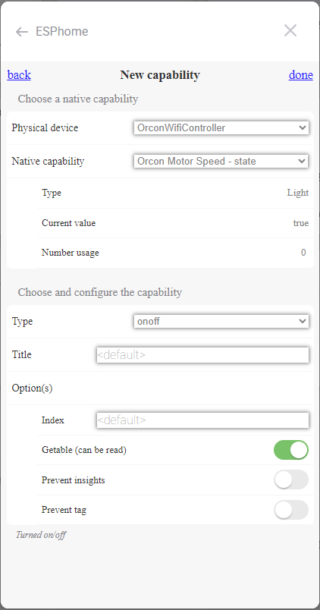
The Motor Speed state must be “On” to control the speed of the fan with the Orcon Wifi Controller. If the Relay is “On” but the Motor Speed is “Off” the fan will not spin.

Motor Speed brightness
The Motor Speed brightness is the setting that controls the fan speed. This one needs to be set to “dim”. You can leave all the values at the default setting and click “done”.
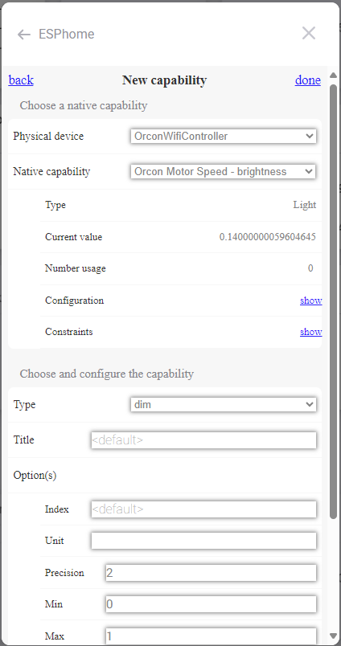

Fan Speed (RPM counter)
To get a good reading of the fan speed we use the “measure_power” type but we need to modify it slightly. Change the title to “Fan Speed” and the Unit to “rpm”.
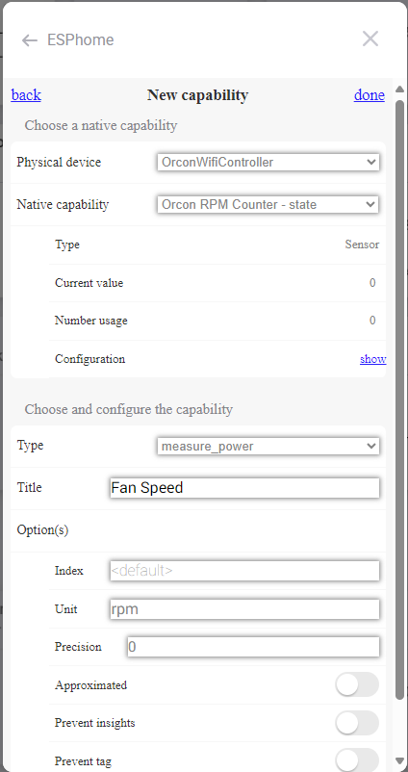

Orcon Factory Remote
To read what speed the Orcon Remote and/or Orcon Sensors would like the fan to spin, we use another “measure_power” type but we need to modify it again. Change the title to “Orcon Remote” the Unit to “RC” and the precision to 4.
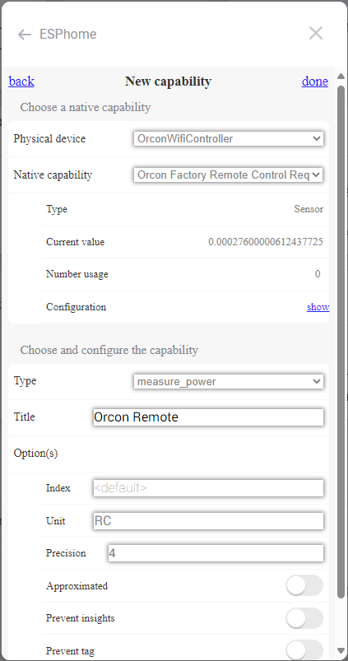
As a result the reading will say:
0.0001 for speed 1
0.0002 for speed 2
0.0003 for speed 3

Temperature, pressure and humidity
To reed these you need the optional BME280 module. Adding the readings is very straightforward;
Orcon Temperature to measure_temperature
Orcon Pressure to measure_pressure
Orcon Humidity to measure_humidity
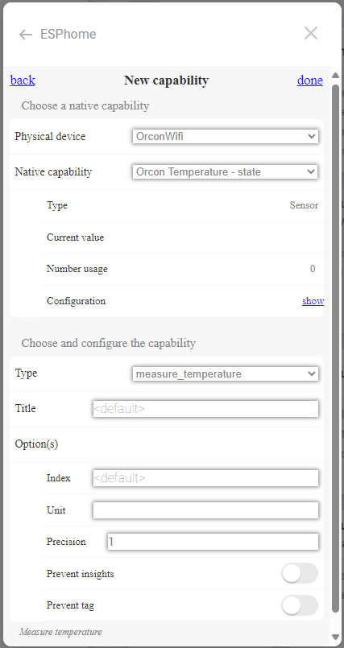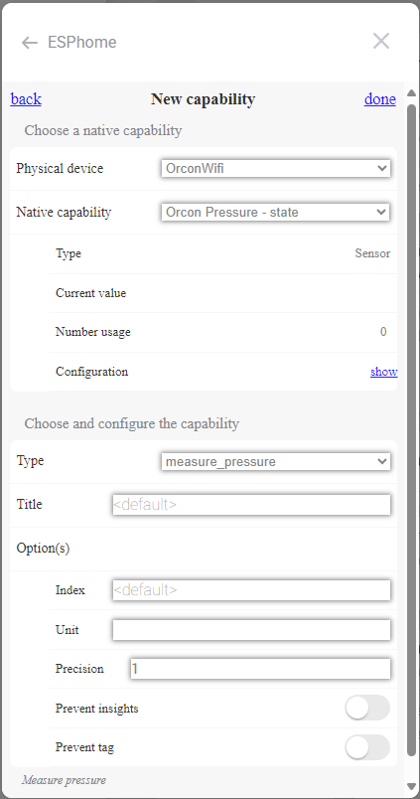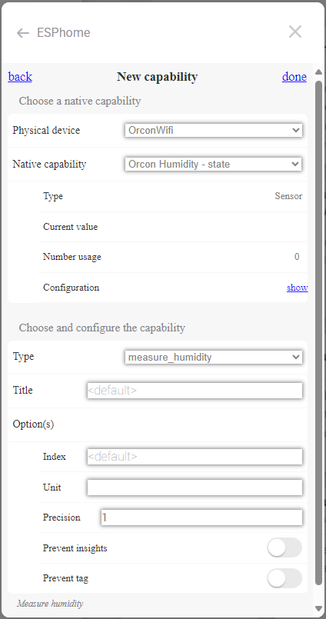

Icon and status indicator
To make things extra pretty in Homey you can change the icon to the ventilation box, name the unit as you like and select which measurement you want to use as a status indicator on the tile.
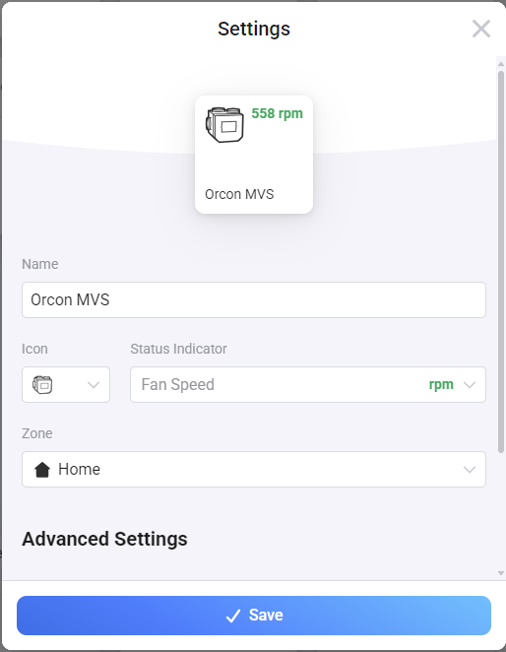

All done! Enjoy writing your automations in Homey!

